Discussion assignment unit 8
Part 1:
Using handling an exception with a try statementis known as catching an exception, which provides an opportunity to fix the problem, or try again, or at least end the program gracefully (Downey, 2015). Generally, catching file-related exceptions using an appropriate action to handle the errors require using try and except blocks in Python. Below is an example of try: except: blocks for handling exceptions:
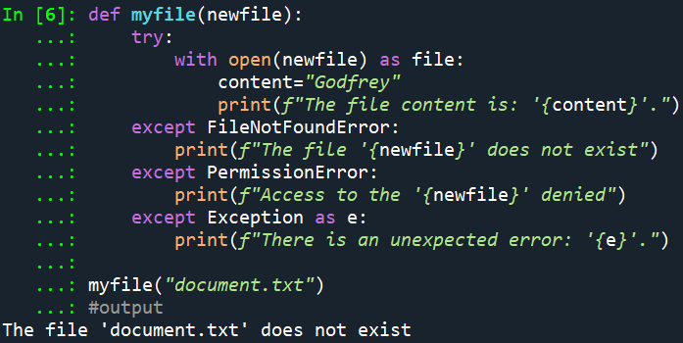
Explanation:
Output of the code above shows that the file "desktop.txt" does not exist in the current working directory, which leads to the FileNotFoundError caught by the except FileNotFoundError block. This output shows the practical use of exception handling when dealing with file operations. The function handles the error gracefully and provides a user-friendly error message, making it clear that the specified file does not exist. Without the exception handling, the code would raise an unhandled exception and might terminate the program abruptly.
Part 2:
A file error arising when writing a large production program can be addressed through exception logging, which can be implemented by using logging module and through that we can log the error (Shivanshsaxena1, 2021). The logging module offers a number of options for basic logging, including DEBUG, INFO, WARNING, ERROR, and CRITICAL. The logging.exception() method in Python is often used to log an exception with an error. This function adds a message to this logger with the status ERROR. The arguments are treated as for the debug() function. To the logging message, exception information is appended. Only exception handlers should call this function (Shivanshsaxena1, 2021).
Question for peers: How can files and directories be removed in Python, and what is a precaution to take while using the removal methods?
Reference
Downey, A. (2015). Think Python: How to think like a computer scientist. Green Tree Press.
Shivanshsaxena1. (2021, September 29). How to log a python exception? GeeksforGeeks. https://www.geeksforgeeks.org/how-to-log-a-python-exception/

